Table : Budget for spring quarter

|  |  |  |  |  |
| --- | --- | --- | --- | --- |
| Name | Duration - days | Begin | End | Costs |
| 1st iteration of final product | 10 | 31/03/14 | 11/04/14 | R$ 1.000,00 |
| 2nd Iteration of final product | 10 | 11/04/14 | 24/04/14 | R$ 2.500,00 |
| Integration of Sub-Systems | 14 | 24/04/14 | 13/05/14 | R$ 1.000,00 |
| 3rd iteration of final product | 14 | 13/05/14 | 30/05/14 | R$ 2.000,00 |
| Finalization of product | 7 | 28/05/14 | 05/06/14 | R$ 700,00 |
| SUDS | 1 | 12/05/14 | 12/05/14 | R$ 1.000,00 |
| EXPE | 28 | 03/05/14 | 10/06/14 | R$ 2.000,00 |
| Emergency Funds | All |  |  | R$ 3.000,00 |

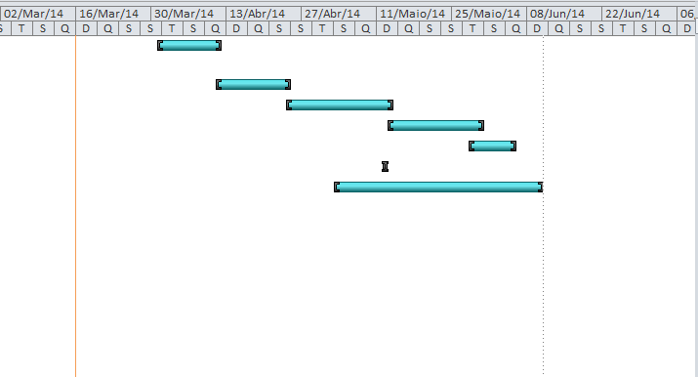

Figure : Gantt Diagram spring quarter